Domain Model Document

Team Name : String Cheese

Team Members :

Chris Schaffer, Meetkumar Savaliya, Tim Stroup, Wei Chen, Ya-Hsin Cheng

Domain Model:

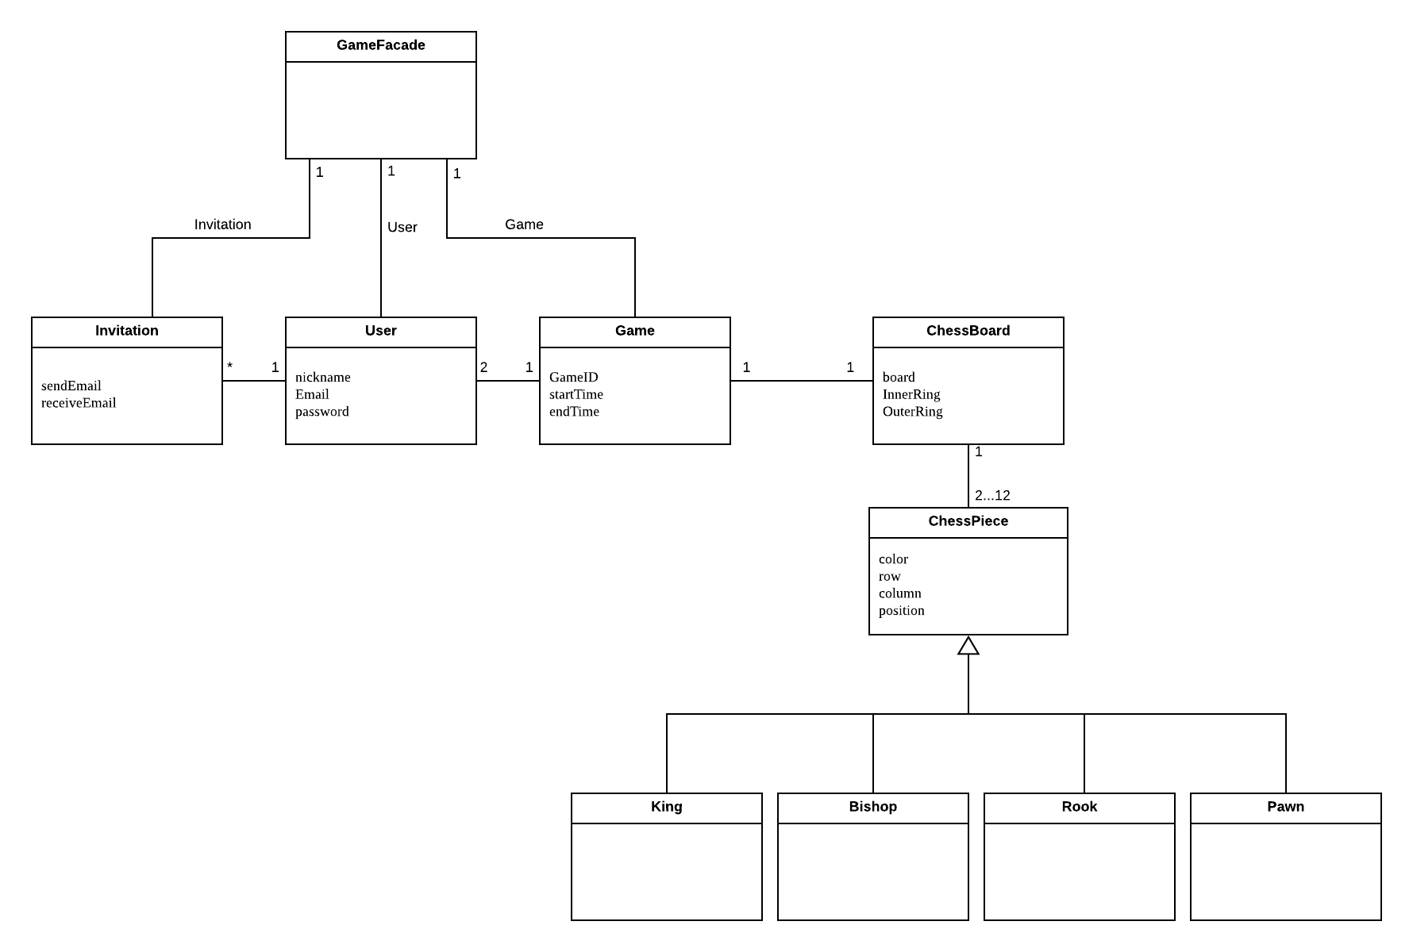

Glossary:

|  |  |
| --- | --- |
| ChessBoard | The board is the combination of spaces that a piece may move and the boundaries of the game. |
| ChessPiece | The game is played with different pieces; each with unique movements and rules. Each player has either six white or six black pieces that include two pawns, one king, one bishop and two rooks. |
| Game | A game consists of two users who take turns moving their pieces around the board. |
| GameFacade | The game facade includes the game, user, and invitation, connect to the UI. Each click from the UI, will pass the action through the game facade to the game, user, or invitation. |
| Invitation | A user may send an invitation to another user as well as receive an invitation from another user to play a game. A user may send multiple invitations to multiple users to play a game. |
| User | A person registered to play the game. They may send invitations to other users to play one or more games at a time. |